# Exploring a Macrium Reflect backup to recover individual files and folders:

1. Browse to the image file that is dated with the date you want to restore from
   1. Note: There may be multiple files from the same date, depending on the formatting of the backup media – it shouldn’t matter which one you choose
2. Right-click on the image file and select “**Explore Image**”

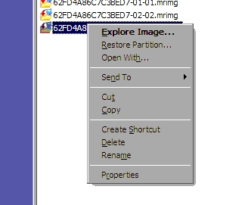

1. You will be presented with a dialog asking which of the partitions that are included in the image you would like to explore. Check all of the partitions you would like access to, if there is a possibility you will require access to folders with restricted access, click the checkbox at the bottom

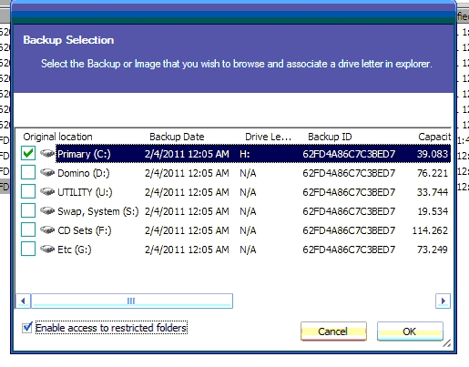

1. The partition(s) will automatically be assigned the next available drive letter(s). You can explore them as if they’re actual drives. Copy files/folders to another location such as your desktop or the location of the original files/folders

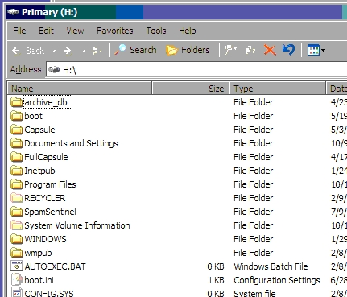

1. When you are done recovering files, to remove the explored image(s) go into My Computer, right-click on the Macrium drive(s), and click on “**Unmount Macrium Image**”

